ANZ Building Planning History – 23-29 Albert Street
There have been several consenting processes relating to this site, some of which seek variations on previous consents. This means there are incremental and cumulative effects that need to be extracted from sequential planning decisions. The first planning decision was in 1987 – though nothing was built. This planning process is explored in the next section. Then in 1988 there were two planning decisions – the first being a variation on the 1987 consent, the second being an application to apply changed district plan provisions to its proposal. These are both explored in the 1988 section of this report. Much of what is now on the site was built according to the 1988 consents. Then in 2011 consent was sought largely relating to public aspects of the site. This is explored in the penultimate section. The report ends with a concluding summary.
The 1987 Resource Consent Process
R_LUC_1987_779-ResourceConsents-Landuseconsent-Application-Planning-3347-580243.pdf
Hawkins Development Ltd made application to Auckland City Council 27th February 1987 for a 31 storey tower at 23-29 Albert Street.
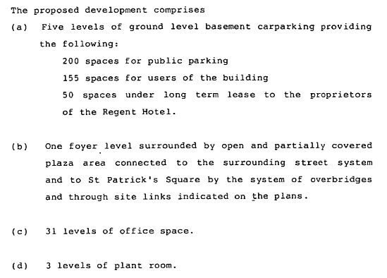
R_LUC_1987_779-ResourceConsents-Landuseconsent-Plan-234-731795.pdf
The plans accompanying the application include site plans for each level, and include a plan illustrating the site through-links and plaza areas proposed to provide bonus floor space needed for additional height. That plan is available at Figure 1, Appendix 1.
R_LUC_1987_779-ResourceConsents-Landuseconsent-Plan-1188-467881.pdf
Other detailed plans are also available, showing the Boffa Miskell landscape proposals. These relate to each of the two plaza levels that were then proposed. These are available at Figure 2, Appendix 1.
R_LUC_1987_779-ResourceConsents-Landuseconsent-Report-2838-844883.pdf
The planning report for the hearing notes among the reasons for the application being needed that: at 152 metres the building exceeds the height control of 55 metres for the area; that it has excess gross floor area; and that the proposed elevated walkway across Swanson Street is over width. The report examines the floor area issue in some mathematical detail, noting the applicant insists that floor area used for public parking and all basement floors should be exempted, and listing the floor area entitlements associated with each of the public amenity components. (NB: the floor area of each of levels 1-34 of this application – masde up of 31 levels less lobby level + 4 service levels – is on average about 1080 m2)
R_LUC_1987_779-ResourceConsents-Landuseconsent-Report-3562-580666.pdf
This appendix (F) to the planning report contains notes on specific bonus floor area provisions. These are summarized as:
- Non residential club. 1115 m2. This has a bonus ratio of 1:1. The report states that the Director of Community and Planning Unit be satisfied that that is what is provided.
- Public toilet. 60 m2. This has bonus ratio of 3:1 – giving an equivalent of 180 m2. The report stipulates that these facilities need to be located in public areas and be accessible to the public to enable the bonus floor area provision to count.
- Pre-school facility. Total floor area of 246m2. Bonus ratio of 3:1. The report indicates that discussions have been had with Dept of Education which provides the criteria under which the facility can be licensed accordingly, and then be counted.
- Plaza. The area of plaza for which bonus is claimed is 1371.5 m2, attracting a bonus of 2:1, and total bonus floor area of 2743m2. The report notes the Boffa Miskel plans for this area and notes that approval from the Executive Manager of Parks and Recreation should be required as to the amenity developed and in regard to the plaza being an “extension of St Patricks Square”.
- Footpath Widening, Escalators, Overpass. These are all noted in terms of area and bonus ratios.
- Through Site Link. The report notes that the District Plan provides for “through site links” which provide “logical pedestrian routes and provide shorter or more convenient routes…” The overall bonus floor area entitlement with this provision is 3150 m2.
The recommendation to planning commissioners is that consent be granted subject to conditions.
R_LUC_1987_649-ResourceConsents-Landuseconsent-ExpertReport-2619-091828
Statement of planning evidence dated 22 July 1987 of G.R. Land - architect of development who won “limited design competition” – includes:
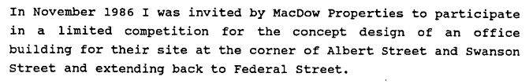
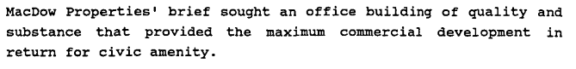
R_LUC_1987_649-ResourceConsents-Landuseconsent-ExpertReport-2621-723537.pdf
Statement of planning evidence dated June 1987 of Boffa Miskell’s Richard Flook – landscape planner and designer – includes:
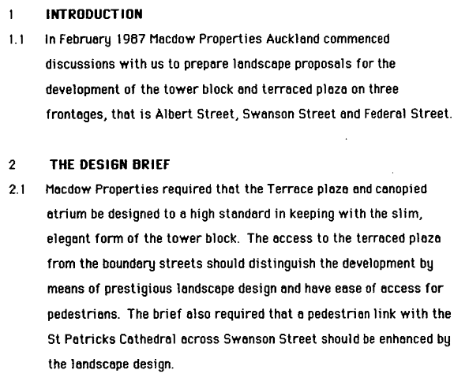
This material, along with site plans and other relevant evidence was considered by the Auckland Council Planning Hearings Committee which dealt with the application on 23rd July 1987, and granted consent, subject to conditions. These included:
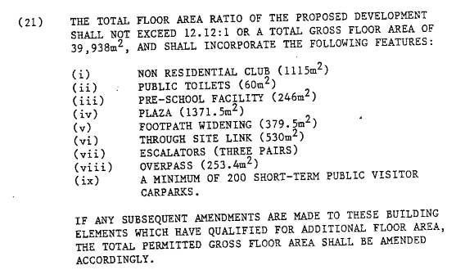
And:
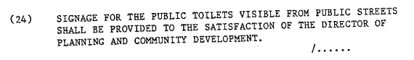

R_LUC_1987_649-ResourceConsents-Landuseconsent-ConsentConditions-Planning-2155-104879.pdf
Because the application proposed public works including the plaza and and the Swanson Street overpass/bridge, related matters needed to be considered by Auckland City Council’s Planning Committee at its meeting of 2 December 1987. It appears that several changes were made to the landscape plan by Boffa Miskell, after the planning hearings decision, and prior to the Auckland Council Planning Committee meeting. These changes are described in a report to Auckland City Council’s Planning and Community Development Department.
R_LUC_1987_649-ResourceConsents-Landuseconsent-Report-1423-348044.pdf
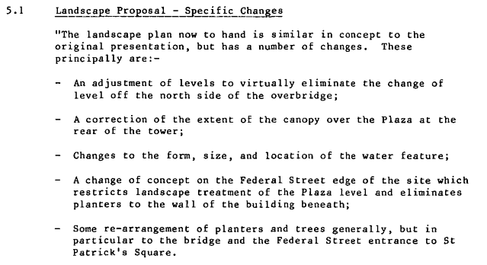
There is some discussion in the archives of the nature of the changes, but the overall advice of Council’s urban design experts is that the new design – which includes changes to planters, to a proposed water feature, and to the overpass – still essentially delivered an appropriate level of public amenity commensurate with the bonus provisions.
R_LUC_1987_649-ResourceConsents-Landuseconsent-Report-461-138514.pdf
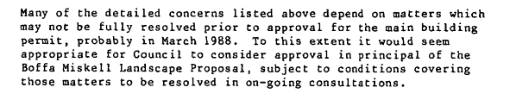
At that meeting Auckland Council’s Planning Committee resolved to support the changed Boffa Miskell landscape plan (with a number of resolutions relating to approvals needed for the plaza and the overpass), noted that all costs would be carried by the developer, required that the public works be approved by Council’s director of planning and community development but that they be subject to consideration by Council’s works committee.
The 1988 Resource Consent Process
Two different resource consent applications relating to 23-29 Albert Street were made in 1988. The first was apparently in response to changes in the economy and reduced the scale of the proposed development, and the second responded to changed bonus floor provision opportunities that became operative after the relevant District Plan provisions were reviewed (it would be of interest to discover how those more generous bonus floor provisions actually got into the District Plan – but that is beyond the scope of the present research.) The first of those 1988 consent applications is reported next, beginning with background describing the economic context and application purpose:
R_LUC_1988_681-ResourceConsents-Landuseconsent-Report-2618-777188.pdf
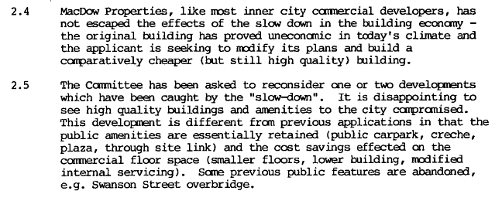
R_LUC_1988_681-ResourceConsents-Landuseconsent-Application-947-650951.pdf
On the 12th May 1988, Macdow Properties, the owner now of 23-29 Albert Street, applied for a variation to the consent obtained the previous year. This application stated:
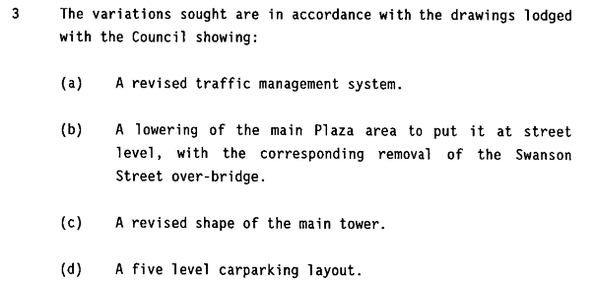
That application was considered and granted with conditions on the 25th of May 1988. In particular the condition relating to floor area was changed:
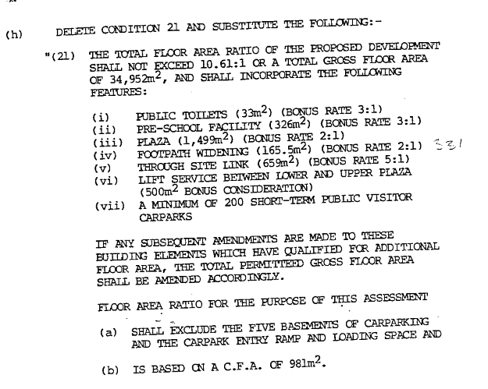
The additional floor area permitted by the combination of: public toilets, pre-school facility, plaza, through site link, and lift service (all of which directly relate to public pedestrian amenity) is equivalent to 7,871 m2, or 8 floors in the tower.
R_LUC_1988_681-ResourceConsents-Landuseconsent-Report-1187-292447.pdf
Further background to this particular application is here:
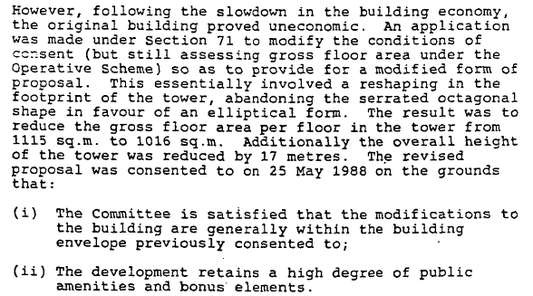
Then in 9th September 1988 the applicant made application to modify conditions of consent consistent with district plan changes relating to more generous bonus floor space provisions. Please refer to Figure 4 in Appendix 1 for a plan showing most of the bonus floor area spaces. The application is described in a planning report dated 3rd October 1988:
R_LUC_1988_681-ResourceConsents-Landuseconsent-Report-1187-292447.pdf
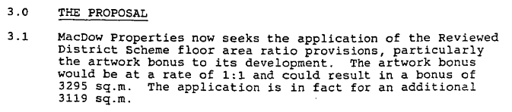
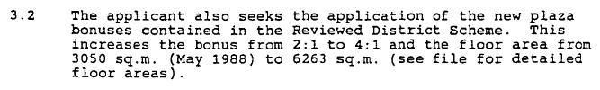
The report recommended that “no hearing was necessary”, that the application could be dealt with under delegated authority if no objection was received from previous objectors (none was).
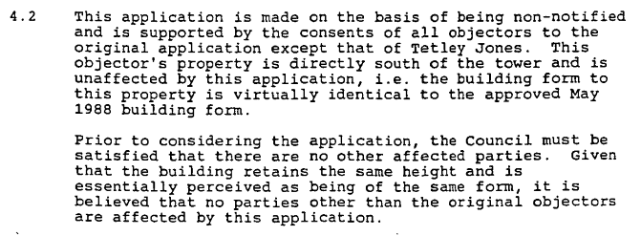
The planning report recommended application be considered without notification and without a hearing and that the application should be granted, with changes to the resource consent conditions, in particular the condition relating to bonus floor space entitlements:
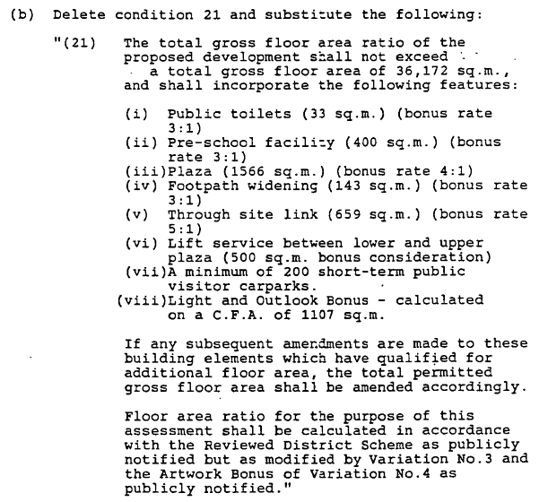
Noting that the height control for the location is 55 metres, and that the height of the building is proposed at around 160 metres, it is interesting to view my rough calculations based on these bonus floor provisions:
- Public toilets 33 x 3 = 99 M2
- Pre-school facility 400 x 3 = 1200 M2
- Plaza 1566 x 4 = 6264 M2
- Footpath widening 143 x 3 = 429 M2
- Through site link 659 x 5 = 3295 M2
- Lift service 500 M2
- Light & Outlook bonus (not known)
- Minimum 200 public car parks (not known whether this contributes to height above gound)
- Artwork bonus 3119 M2
- Total 14906 M2 - which is equivalent to about 15 floors.
Accordingly, the applicant was advised by letter dated 19th October 1988 that consent had been granted.
The 2011 Resource Consent Process
The application lodged 29th April 2011 by Barker & Associates acting for the property owner (AMP NZ Office Albert Street Ltd) is under the heading “ANZ Centre Refurbishment” and states:
R_LUC_2011_1533-ResourceConsents-Landuseconsent-Application-3470-629608.pdf
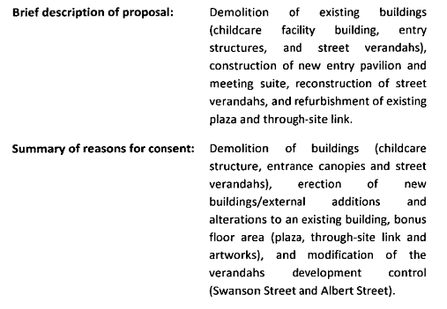
Further background explanation is provided:
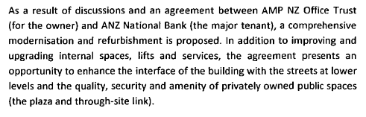
In explaining the need for resource consent the application states:
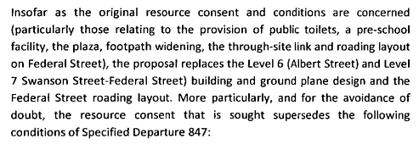
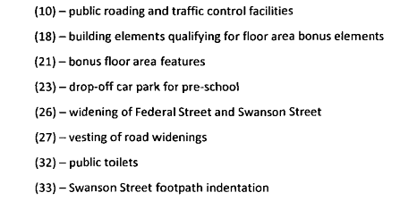
Attention is drawn to what this means: that resource consent is sought to – among other things – supersede condition 21 which in all previous consents (1987 and 1988) has described the public amenity requirements and related bonus floor entitlements. The assessment of effects in the application notes that the childcare facility is to be demolished and goes on to state:
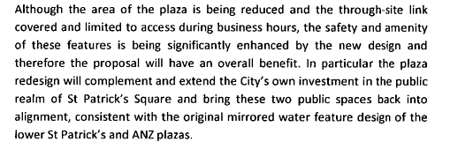
The application report advises that the changes were generally supported by Warren and Mahoney architects, an independent urban designer, and when considered by the Auckland Urban Design Panel. Though I note that none of the information available in the files indicates that the planning history for the building in terms of bonus floor provisions that were conditions of consent, was part of that consideration. For example, the power point presentation given to the Auckland Urban Design Panel does not traverse the 1987-1988 planning history in relation to the public amenity obligations that then applied and required bonus floor provisions. The application report contains this advice:
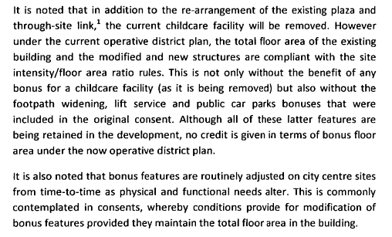
I take this to mean that – in the applicant planner’s opinion - had the tower building been applied for and consented in 2011, the district plan provisions operative then would have allowed it to be built at that height and with its gross floor area, but without any of the bonus floor requirements that applied in 1988. The resource consent application was not notified. The decision to grant consent is dated 13 June 2011 and contains these conditions:
R_LUC_2011_1533-ResourceConsents-Landuseconsent-Other-3238-813737.pdf
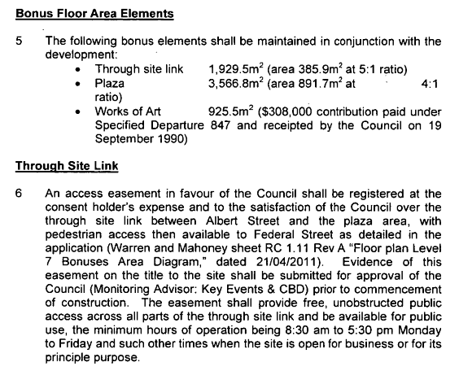
The reader is invited to compare the surface areas of the site link and the plaza with what had been consented previously, and note the loss of public toilets and suchlike.
Summary and Concluding Remarks
Auckland City Council planning provisions in the 1980’s were effective in requiring public amenity in exchange for height and gross floor area “departures” in proposed new tower buildings in the CBD. Planners had specific controls that could be applied providing measureable public amenity – such as through links, open space, creche facilities, public toilets and of reasonable quality (ie requiring these facilities be designed by an authority such as Boffa Miskel). However as the CBD has developed, district plan provisions have been relaxed, putting at risk public amenity and facilities that had been put in place earlier. Defenders of public amenity need to be aware of the risk posed through district plan changes which – when applied later – can be used to reverse conditions which hitherto required that public amenity.

