SCHOOL/DEPARTMENT School of Architecture and Planning /Planning Programme

COURSE OUTLINE: MUrbPlan 704 2017 Semester 1

1.0 GENERAL COURSE INFORMATION
- Course Code: MUrbPlan 704
- Course Title: People Communities and Planning
- Points Value: 15
- Prerequisites: None
- Restrictions: None
- Course coordinator / teaching staff:
Co-ordinator and teaching: Professor Dory Reeves.
Office Hour: Thursday 3-4pm
411, 26 Symonds Street. No appointment necessary. Part time students may need to make an appointment outside this office hour time.

2.0 CLASS CONTACT HOURS

Both sessions are in: Planning 619/421E-619
Tuesday  Friday | 2:00pm – 3pm  2.00pm – 4pm

3.0 COURSE PRESCRIPTION

‘A critical analysis of urban social issues and relevant planning responses.’

4.0 TEACHING AIMS

The aims of this course are to: provide an introduction to the social aspects of planning, to ensure that students understand the issues affecting different groups of people and how planning may respond. The two assignments have been carefully designed to enable you to demonstrate the learning outcomes/ objectives. This course will focus on the public realm/public spaces. Other courses will focus on housing, the environment and transport.

5.0 LEARNING OUTCOME OBJECTIVES
On the successful completion of this course, students will be able to:
- Demonstrate an understanding of the social issues affecting individuals, families and communities in urban areas, including the provision of social infrastructure, with a focus on public open spaces.
- Demonstrate an understanding of relevant current urban planning and urban design responses and the global context.
- Formulate policies, plans and urban design responses for a more inclusive and sustainable urbanism.
- Demonstrate an understanding of cultural competency and have the ability to apply the concepts within a range of cultural contexts.
- Demonstrate an understanding of qualitative research methods.
- Demonstrate Academic Literacy Skills.
How the Learning Outcome Objectives are achieved
Learning Outcome Objectives | How they relate to Part 1 and Assignment 1 | How they relate to Part 2 and Assignment 2
Demonstrate an understanding of the social issues affecting individuals, families and communities in urban areas, including the provision of social infrastructure | By carrying out and completing an assessment of social needs for public space through desk research and direct contact with community representatives. | Building on assignment 1, by undertaking a review of research and producing a report, which sets out the lived experiences, issues, needs and priorities of individuals and families with seniors and young people.
Demonstrate an understanding of relevant current urban planning and urban design responses | Through an investigation of public open space policy in Auckland. | Through an investigation of the relevant sections of the Auckland unitary plan and city centre plan.
Formulate policies, plans and urban design responses for a more inclusive and sustainable urbanism | By suggesting how open spaces might be improved to meet the needs of users from Splice. | By suggesting how the spaces can be improved based on the literature search.
Demonstrate an understanding of cultural competency and have the ability to apply the concepts within a range of cultural contexts | By carrying out and completing a cultural competency exercise to see how we categorise people affects the decisions we make as planners | By reflecting on and applying the cultural competence tool introduced for assignment 1 and your perception of particular groups of people.
Demonstrate an understanding of qualitative research methods | By meeting with community representatives and undertaking a qualitative assessment of spaces | Through the literature search capturing story and narrative based research.
Demonstrate Academic Literacy | By using Refworks to manage bibliographies.  Sharing information on Dropbox | By using Refworks to manage bibliographies.  Sharing information on Dropbox

Course content - Activities
Week /  date | Tuesday | Friday
Wk 1 Starts  Tuesday  March 7th | Introductions; Aims,  Learning outcome objectives,  activities and assessment.  Feedback from 2016 and changes  Self-assessment: experience of  Planning (in NZ or elsewhere)  Refworks;  Easy Read,  Questions  See readings for Friday | Part 1: An introduction to contemporary  social issues and the concepts of social capital,  demographics and intersectionality.  Part 2: Cultural Competence:  Understanding how our perceptions affect  the decisions we make  Discussion
Wk 2 Starts  Tuesday  March 14th | Confirming understanding of  learning outcome objectives  The Global Responses –  Sustainable Development Goals  and the New Urban Agenda.  Project for Public Spaces (PPS)  a way of assessing places and  spaces | Meeting with Community Group Reps’ Splice  and the Department of Internal Affairs to:  understand their need and roles. Venue:  Waitemata Local Board Offices, TBC  Get feedback on the site assessment tool  and how it can be developed to meet the  needs
Wk 3 Starts  Tuesday  March 21st | Library search session planning  the search for material for  Assignment 1 on relevant  examples from elsewhere. | Visit to the Auckland Council Service Centre  at 35 Graham Street off Victoria Street to find  out how to access Resource Consents and  other relevant information on the spaces.
Wk 4 Starts  Tuesday  March 28th | How to assess and document open  spaces. | Field work: Site visits and assessments
Wk 5 Starts  Tuesday  April 4th | Easy Read summaries; why  produce them and what they  need to look like | Meeting with SPLICE to present the results  of the field - work and literature search.
Wk 6 Starts  Tuesday  April 11th | Reflection on the Friday  presentations and what needs  doing for the final reports.  Feedback  Assignment 1 to be submitted  by 5pm on Friday 21st April. | MID SEMESTER  STUDY BREAK and EASTER  Friday April 14th until  Saturday April 29th
Part 2
Wk 7 Starts  Tuesday  May 2nd | Assignment 2; Activities and  Programme.  Feedback and learning on the  Assignment 1 | An introduction to the issue of the age  friendly city and the application of  intersectionality.  Activity to identify the lived experiences  of the 704 class.
Wk 8 Starts  Tuesday  May 9th | Advanced library search for  Assignment 2 to identify experiences  issues and needs of seniors and  younger people with regard to  open spaces | An introduction to the equity gap.  Activity to identify the issues,  needs and priorities of the 704 class.
Wk 9 Starts  Tuesday  May 16th | Understanding the statutory  duties in NZ and the processes. How  does policy get translated to action? | Collating the international examples presented  by the class in assignment 1  The role of Local Boards and a Local Board Plan  The role of ADCOSS and other non-profits  in relation the local boards and advisory  groups.
Wk 10 Starts  Tuesday  May 23rd | How the Council gets advice?  The Advisory Panels  Greg Morgan from  Auckland Council TBC | Accessible spaces  Led by the ‘Be accessible’ team
Wk 11 Starts  Monday  May 30th | Producing an excellent literature  review | Class presentation of the results of the  literature search and review  focussing on the lived experiences  Issues and needs of seniors and younger  People with regard to open space.
Week 12  Tuesday  June 6th  Week 13 | Working in community based  Planning. What are the opportunities  and how to best prepare yourself  Assignment 2 hand in Monday  June 12th 5pm | The content and format of this session will  Be discussed with the class in advance and  depend on the needs of the assignment 2.

Study Hours
A standard 15 point course represents 150 hours of study. You will need to allocate your time between the following:
- Face to face teaching and learning sessions on the Tuesdays and Fridays
- General reading
- Assignment specific reading
- Resource consent work
- Literature search and review
- Reflection

Learning resources: see Canvas which will link to Talis, the online reading list.

Also: Auckland Council runs a public series of talks called ‘Auckland Conversations’ Register your interest with Auckland Council http://conversations.aucklandcouncil.govt.nz/ and they will send you reminders and advise of future Conversations.

Inclusive Learning:

Students are urged to discuss privately any impairment-related requirements face-to-face and/or in written form with the course convenor/lecturer and/or tutor.

Student feedback

Each year student feedback is used to improve the course and this will be explained in week 1. Students are encouraged to give feedback throughout the course

Assignment 1

Background

In 2016 we started to work with an inner city community group called Splice. Their aim is to build community and connectedness in Auckland City Centre. They acknowledge the traditional Kaitiaki and Mana Whenua of Tamaki Makaurau. One of the issues which they are concerned about and which overlaps with planning is the design and location of public open spaces. A survey of 30 small public open spaces was undertaken by students last year as part of this course.

A compilation of student assignments was made available: https://cdn.auckland.ac.nz/assets/creative/schools-programmes-centres/architecture-and planning/An%20assessment%20of%20bonus%20floor%20spaces%20in%20Auckland%202016%20.pdf

Assignment 1 2017

Assignment 1 continues the collaboration into 2017 and will build on the work that has been done. The aim of this assignment is to introduce you to the process of understanding a city from both an individual and community perspective leading to a report on how people use the city.

Each group will be allocated 2 open spaces (1 known bonus floor spaces and 1 investigation space) both of which have been identified by the community group. (see appendix 1) The community group (Splice) want you to find out more about the spaces by looking at the original resource consents; documenting the sites and undertaking an assessment, based on the needs of the community made up of families and individuals.

The assignment requires each person to submit a 15 page report (excluding the list of references) containing the following:
- Easy read executive summary
- Introduction setting out the purpose of the report
- Literature review: what are public spaces for?, why are they important? and what interesting examples could Auckland learn from building on the examples in the following report?: http://www.aucklandcouncil.govt.nz/EN/newseventsculture/communityfundingsupport/Documents/communitiesshapingtheirplaces.pdf
- Detailed descriptions of the 2 assigned spaces
- Well labelled photos and location maps, cultural references, extracts from the resource consents - with explanation shared on drop box
- Summary of the site assessments matched against the needs of the community (Splice) undertaken using the site assessment tool
- Conclusion
- Self-reflection of the process

The assignment must be written in formal language using correct spelling and grammar. All information sources used are appropriately referenced using the APA style, both within the text and in the bibliography.
Marking Criteria for Assignment 1 | A | B | C | D FAIL
15 page report
Easy read exec summary (10%)
Introduction (5%)
Literature review (15%)
Summary of site assessments against client needs (25%)
Text, photos and maps in report and on Dropbox (10%)
Summary of the key relevant information from the resource consents (15%)
Conclusions (5%)
Self-reflection of the process (10%)
References on Refworks (5%)

Appendix 1
Five Known Social Spaces:
1. Princes Wharf – overall the whole wharf - what is public (including the upstairs view point) and what are the opening hours?
2. 56 Wakefield St – The AUT Observation Deck.
3. 188 Quay St - PWC Tower –space including a public artwork between the escalators; what is public, what is public but masquerading as part of the café?
4. 1 Khartoum Place – Gloria Jeans – the throughway is one part of the overall picture, there is a side room downstairs that is understood to be public space (possibly) although Gloria Jeans has a sign on the pillar.
5. TBC
Five Investigation Spaces:
Splice have provided some notes to guide your enquiry. You also need to look out for other information useful to the community living in the city.
1. 41 Shortland St – AIG Building. For a long time there used to be a large open space out the front of this tower. Pilkingtons restaurant is now a fairly permanent structure sitting across the open space and it replaced a predecessor restaurant which was a far more temporary structure. Was there a requirement for open space in the original consent that has been done away with over time?
2. 23 – 29 Albert St – ANZ Tower. There used to be a lot more open space around this tower and it definitely had requirements on the original consent. A walkway around the building has now been closed in and is only open during certain hours and closed in the weekend. So the question: is it public still inside the now enclosed area; why are there so many “no loitering” signs on the outside the building; some people say the consent required a crèche which is no longer there.
3. 74 – 88 Shortland St – Lumley Centre – It has a great throughway between Fort and Shortland but what about the rock garden and balcony area overlooking Fort St – also public and if so why can’t it be accessed during the weekend?
4. 66 Wyndham St – Chorus House – There is a very significant amount of covered space particularly on the Hobson St side of this building that looks suspiciously as if it could be public space? Is it or is it private and was built with some other purpose in mind that never came to pass?
5. 125 Queen St – Queens Rise (formerly the BNZ Tower and often still referred to as) – There was supposed to be Observation Deck with this tower.

We are required to include the University statement detailed below on our course outlines. It does not preclude group work and collaboration.

Academic Integrity

The University of Auckland will not tolerate cheating, or assisting others to cheat, and views cheating in coursework as a serious academic offence. The work that a student submits for grading must be the student's own work, reflecting his or her learning. Where work from other sources is used, it must be properly acknowledged and referenced. This requirement also applies to sources on the world-wide web. A student's assessed work may be reviewed against electronic source material using computerised detection mechanisms. Upon reasonable request, students may be required to provide an electronic version of their work for computerised review.

Assignment 2

Assignment 2 will also build on assignment 1. This time we will be taking a much more disaggregated look at the community to assess the specific needs, how these are moderated by intersectionality and what these mean for the city. You will be taking other courses focusing on housing, the environment and transport, so in this course we will continue to look at public space.
Based on desk based research, prepare a 15 page report (excluding references) for the Auckland District Council for Social Services (ADCOSS). [ADCOSS is an incorporated society, acting as an umbrella organisation covering the Auckland isthmus and including groups and individuals committed to the ADCOSS mission statement.] The report needs to be highly accessible and based on a rigorous review of a well-executed literature search and review of qualitative research.The report will set out the lived experiences, needs and priorities facing seniors and younger people in Auckland along with examples of how the planning and design of the city’s open spaces could be improved. When researching you are required to demonstrate awareness of and acknowledge the impact of intersectionality when it comes to: culture, ethnicity, gender and sexual orientation and disability. This report will involve primarily desk based research.
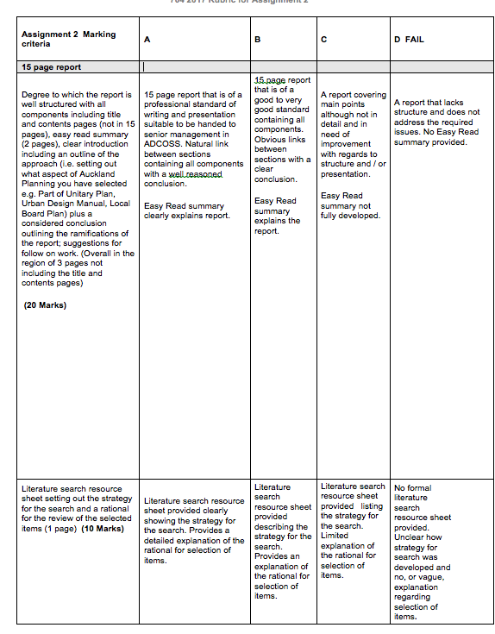

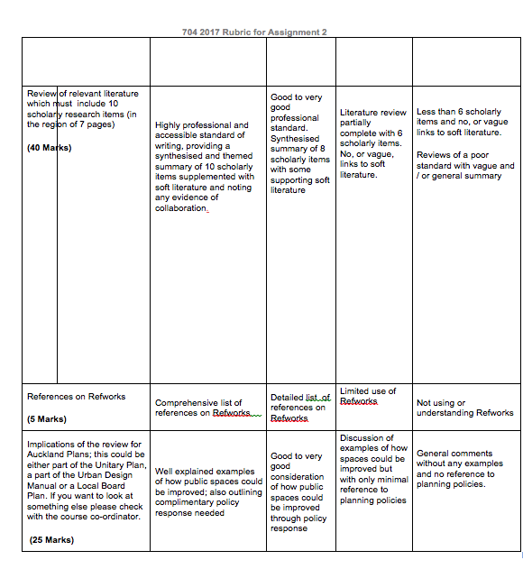

Literature search resource activity

Question 1
In 2-3 sentences describe your understanding of the assignment question. This will help you search for relevant readings and information.

What is the assignment asking me to do?

Question 2
What are the key ideas, phrases and terms in your topic? These may not necessarily be explicitly stated in the question - think about synonyms, related terms and wider context. Tip: You can use these words to search for and find relevant literature and information on your assignment topic.

Keywords and phrases for my topic are:

Question 3
Name at least three library search tools you are planning to use to find information and readings.

The tools I will use to search for readings are:

Question 4
Using APA referencing style, list 10 items that you will use (cite, reference).

My five references are:

Question 5
Describe in 150 to 200 words (max) why you have selected these five references.

How does each reading support my assignment questions? Why are they relevant? How do they approach the topic?

